Given 3 positives numbers a, b and c. Return the minimum flips required in some bits of a and b to make ( a OR b == c ). (bitwise OR operation).  
Flip operation consists of change **any** single bit 1 to 0 or change the bit 0 to 1 in their binary representation.

**Example 1:**

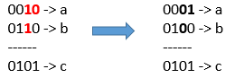

**Input:** a = 2, b = 6, c = 5

**Output:** 3

**Explanation:** After flips a = 1 , b = 4 , c = 5 such that (a OR b == c)

**Example 2:**

**Input:** a = 4, b = 2, c = 7

**Output:** 1

**Example 3:**

**Input:** a = 1, b = 2, c = 3

**Output:** 0

**Constraints:**

* 1 <= a <= 10^9
* 1 <= b <= 10^9
* 1 <= c <= 10^9